The Origins Of WWII[1] C:\Documents and Settings\scpeters\Local Settings\Temp\Temporary Internet Files\Content.IE5\TVNMXOVL\MCj03378760000[1].wmf[2]

Grade Lvl: 10-12 Stephen Peterson

|  |  |
| --- | --- |
| Overview | The goal of this lesson plan is to teach the students the events contributing to WWII. (i.e. Hitler’s rise in Germany, Treaty of Versailles, etc.) |
| Objectives | 1) Students should be able to answer questions that are based on the previous evenings reading assignment.  2)Students should be able to explain how the treaty of Versailles contributed to Hitler’s rise to power in Germany.  3)Students should be able to state the importance of the Munich Conference and why it is negatively viewed today.  4)Students will be able to identify the important countries that contributed to the start of the war.  5)Students will be able to navigate and create an informational website on Weebly.com. |
| Standards | WH 8.4 -Identify and analyze the causes, events and consequences of World War II.  WH.8.5 Explain the origins and purposes of international alliances in the context of World War I and World War II.  INTASC 6.1 models effective communication strategies in conveying ideas and information and when asking questions (e.g., monitoring the effects of messages; restating ideas and drawing connections; using visual, aural, and kinesthetic cues; being sensitive to nonverbal cues both given and received). |
| Materials | Textbook, Notes, Map Handout, Transparency of Europe, PowerPoint Questions, Worksheet, Library Computer |
| Procedures | 1)Start with an introduction that they may be able to relate to. (i.e. Have you ever had a bully?) Then show the relationship between this example and the way the Germans felt about the Treaty of Versailles.  2)Use a question and answer session (about 20 mins) to discuss the previous night’s reading. Use PowerPoint to show questions on pull-down screen.  3)Hand out the information about the website development project.  4)Explain to the students that they will be creating a website on Weebly.com about one of the people who played a large part in the beginning of World War II, Informing them that they are not to use Hitler as their subject.  5)Students will present their website in 3 weeks. |
| Evaluation | Project evaluation will let the students gather information on subjects that played a large role in the beginning of World War II. The presentation will allow the entire class to gain information on many of the influences of World War II. The students will be evaluated on the information they provide and how organized it is on the website. |

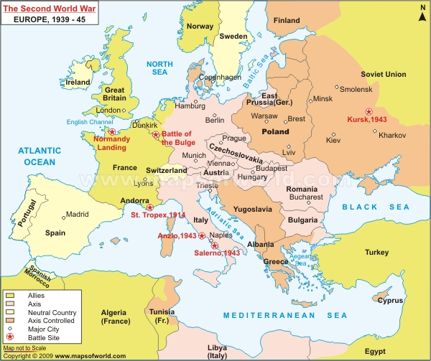[3]

This is the map that will be provided for the students to help them sift through the information that they acquire.

1. http://www.lessonplanspage.com/SSOriginsOfWWIIDiscussionAndWorksheets1012.htm
2. Microsoft Clip Art
3. http://www.mapsofworld.com/world-maps/image/world-war-2.jpg